**Designs Patterns**

As per the design pattern reference book **Design Patterns - Elements of Reusable Object-Oriented Software** , there are 23 design patterns which can be classified in three categories: Creational, Structural and Behavioral patterns. We'll also discuss another category of design pattern: J2EE design patterns.

1. **Creational Patterns**

These design patterns provide a way to create objects while hiding the creation logic, rather than instantiating objects directly using new operator. This gives program more flexibility in deciding which objects need to be created for a given use case.

Creational design patterns are concerned with**the way of creating objects.** These design patterns are used when a decision must be made at the time of instantiation of a class (i.e. creating an object of a class).

But everyone knows an object is created by using new keyword in java. For example:

Example:

StudentRecord s1=**new** StudentRecord();

Hard-Coded code is not the good programming approach. Here, we are creating the instance by using the new keyword. Sometimes, the nature of the object must be changed according to the nature of the program. In such cases, we must get the help of creational design patterns to provide more general and flexible approach.

types of Creational Design Pattern

1. **Singleton** – Ensures that at most only one instance of an object exists throughout application
2. **Factory Method** – Creates objects of several related classes without specifying the exact object to be created
3. **Abstract Factory** – Creates families of related dependent objects
4. **Builder –**Constructs complex objects using step-by-step approach

* Singleton Design Pattern: The Singleton Design Pattern aims to keep a check on initialization of objects of a particular class by**ensuring that only one instance of the object exists throughout the Java Virtual Machine.**

A Singleton class also provides one unique global access point to the object so that each subsequent call to the access point returns only that particular object.

Singleton Design Pattern Example:

So here, we're going to follow a more optimal approach that makes use of a static inner class:

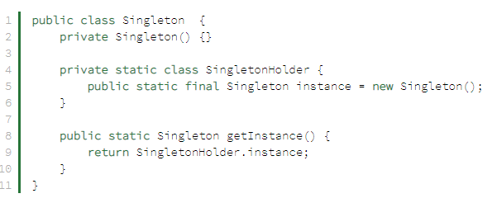

Here, we've created a *static*inner class that holds the instance of the *Singleton* class. It creates the instance only when someone calls the *getInstance()* method and not when the outer class is loaded.

This is a widely used approach for a Singleton class as it doesn’t require synchronization, is thread safe, enforces lazy initialization and has comparatively less boilerplate.

**When to Use Singleton Design Pattern**

* For resources that are expensive to create (like database connection objects)
* It's good practice to keep all loggers as Singletons which increases performance
* Classes which provide access to configuration settings for the application
* Classes that contain resources that are accessed in shared mode
* Factory Method: The Factory Design Pattern or Factory Method Design Pattern is one of the most used design patterns in Java.
* According to GoF, this pattern **“defines an interface for creating an object, but let subclasses decide which class to instantiate.** The Factory method lets a class defer instantiation to subclasses”.
* **Factory Method** is a creational design pattern that provides an interface for creating objects in a superclass, but allows subclasses to alter the type of objects that will be created.

Imagine that you’re creating a logistics management application. The first version of your app can only handle transportation by trucks, so the bulk of your code lives inside the Truck class.

After a while, your app becomes pretty popular. Each day you receive dozens of requests from sea transportation companies to incorporate sea logistics into the app.

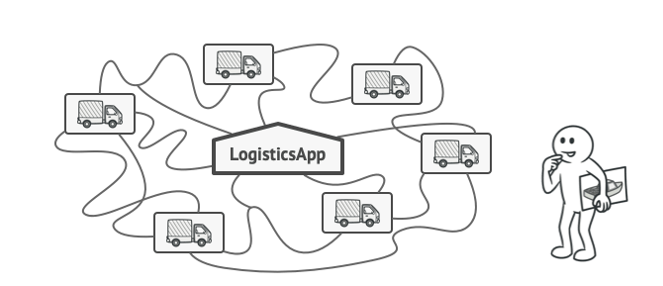

Great news, right? But how about the code? At present, most of your code is coupled to the Truck class. Adding Ships into the app would require making changes to the entire codebase. Moreover, if later you decide to add another type of transportation to the app, you will probably need to make all of these changes again.

As a result, you will end up with pretty nasty code, riddled with conditionals that switch the app’s behavior depending on the class of transportation objects.

**Implementations:**

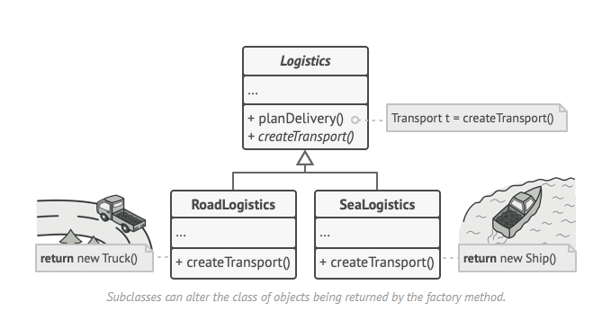

At first glance, this change may look pointless: we just moved the constructor call from one part of the program to another. However, consider this: now you can override the factory method in a subclass and change the class of products being created by the method.

There’s a slight limitation though: subclasses may return different types of products only if these products have a common base class or interface. Also, the factory method in the base class should have its return type declared as this interface.

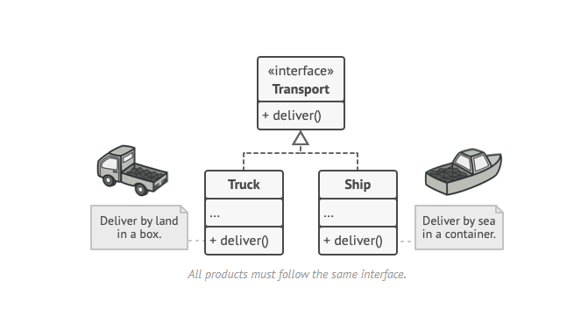

For example, both Truck and Ship classes should implement the Transport interface, which declares a method called deliver. Each class implements this method differently: trucks deliver cargo by land, ships deliver cargo by sea. The factory method in the RoadLogistics class returns truck objects, whereas the factory method in the SeaLogistics class returns ships.

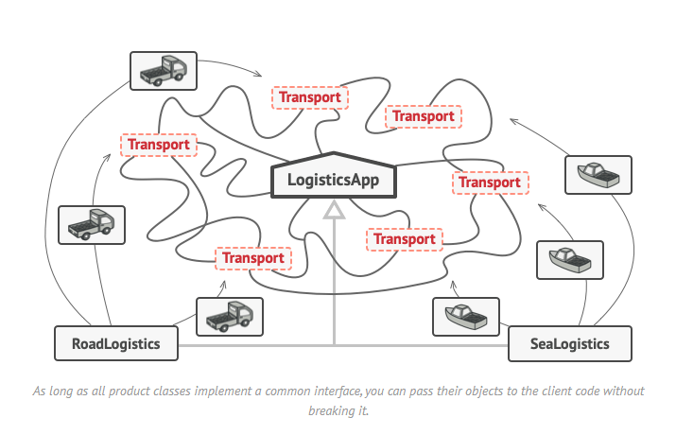

* Abstract Factory: **Abstract Factory** is a creational design pattern that lets you produce families of related objects without specifying their concrete classes**.**

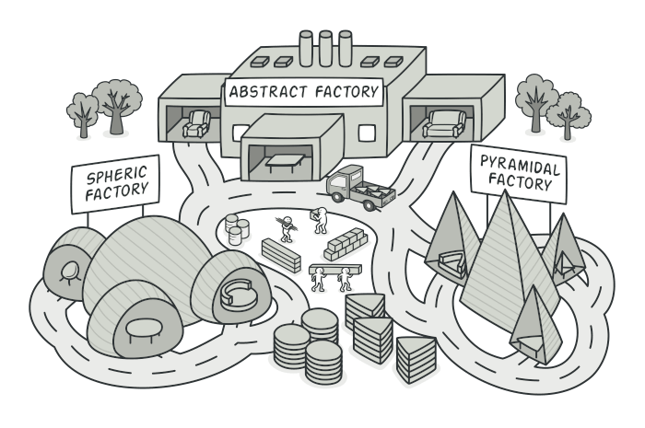

Imagine that you’re creating a furniture shop simulator. Your code consists of classes that represent:

1. A family of related products, say: Chair + Sofa + CoffeeTable.
2. Several variants of this family. For example, products Chair + Sofa + CoffeeTable are available in these variants: Modern, Victorian, ArtDeco.

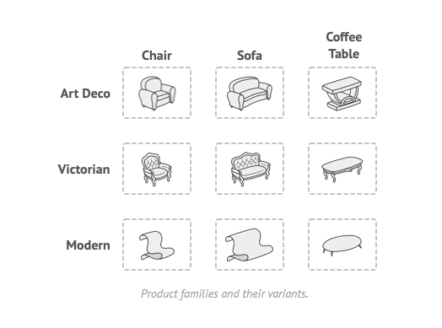

You need a way to create individual furniture objects so that they match other objects of the same family. Customers get quite mad when they receive non-matching furniture.

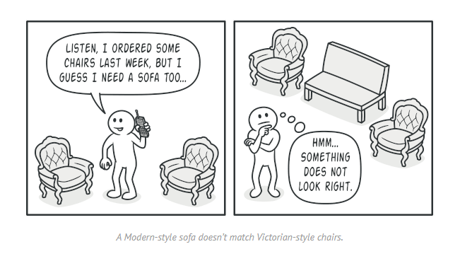

Also, you don’t want to change existing code when adding new products or families of products to the program. Furniture vendors update their catalogs very often, and you wouldn’t want to change the core code each time it happens.

Implementations:

The first thing the Abstract Factory pattern suggests is to explicitly declare interfaces for each distinct product of the product family (e.g., chair, sofa or coffee table). Then you can make all variants of products follow those interfaces. For example, all chair variants can implement the Chair interface; all coffee table variants can implement the CoffeeTable interface, and so on.

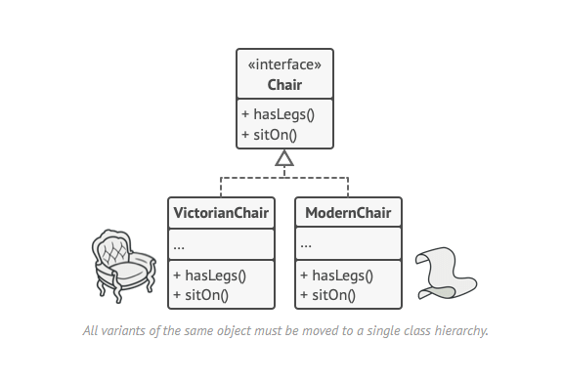

Now, how about the product variants? For each variant of a product family, we create a separate factory class based on the AbstractFactory interface. A factory is a class that returns products of a particular kind. For example, the ModernFurnitureFactory can only create ModernChair, ModernSofa and ModernCoffeeTable objects.

The client code has to work with both factories and products via their respective abstract interfaces. This lets you change the type of a factory that you pass to the client code, as well as the product variant that the client code receives, without breaking the actual client code.

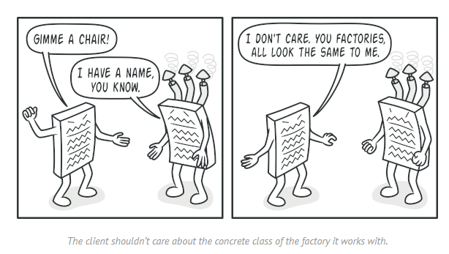

Say the client wants a factory to produce a chair. The client doesn’t have to be aware of the factory’s class, nor does it matter what kind of chair it gets. Whether it’s a Modern model or a Victorian-style chair, the client must treat all chairs in the same manner, using the abstract Chair interface. With this approach, the only thing that the client knows about the chair is that it implements the sitOn method in some way. Also, whichever variant of the chair is returned, it’ll always match the type of sofa or coffee table produced by the same factory object.

There’s one more thing left to clarify: if the client is only exposed to the abstract interfaces, what creates the actual factory objects? Usually, the application creates a concrete factory object at the initialization stage. Just before that, the app must select the factory type depending on the configuration or the environment settings.

* Builder: **Builder** is a creational design pattern that lets you construct complex objects step by step. The pattern allows you to produce different types and representations of an object using the same construction code.

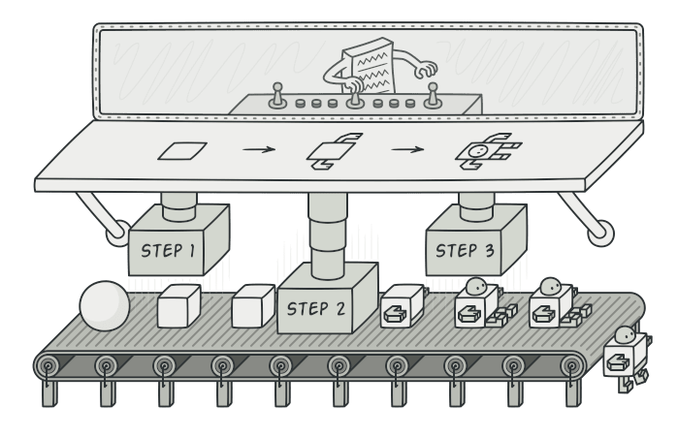

Imagine a complex object that requires laborious, step-by-step initialization of many fields and nested objects. Such initialization code is usually buried inside a monstrous constructor with lots of parameters. Or even worse: scattered all over the client code.

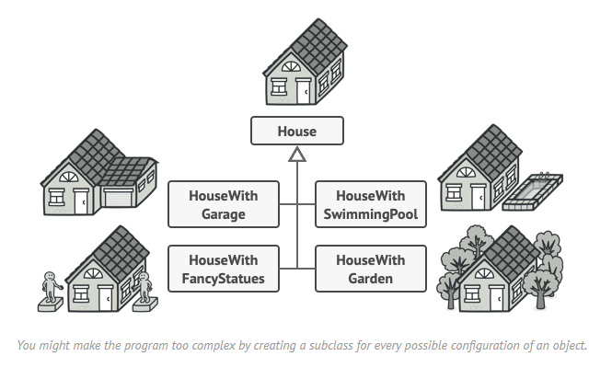

For example, let’s think about how to create a House object. To build a simple house, you need to construct four walls and a floor, install a door, fit a pair of windows, and build a roof. But what if you want a bigger, brighter house, with a backyard and other goodies (like a heating system, plumbing, and electrical wiring)?

The simplest solution is to extend the base House class and create a set of subclasses to cover all combinations of the parameters. But eventually you’ll end up with a considerable number of subclasses. Any new parameter, such as the porch style, will require growing this hierarchy even more.

There’s another approach that doesn’t involve breeding subclasses. You can create a giant constructor right in the base House class with all possible parameters that control the house object. While this approach indeed eliminates the need for subclasses, it creates another problem.

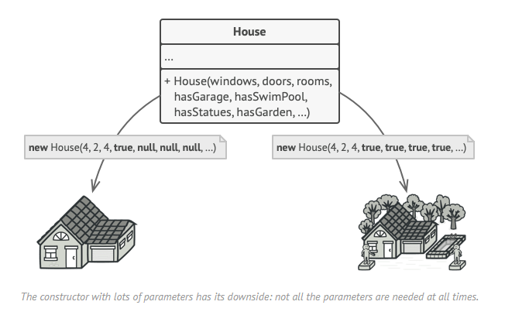

In most cases most of the parameters will be unused, making [**the constructor calls pretty ugly**](https://refactoring.guru/smells/long-parameter-list). For instance, only a fraction of houses has swimming pools, so the parameters related to swimming pools will be useless nine times out of ten.

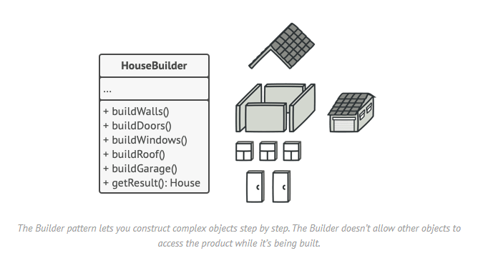

The pattern organizes object construction into a set of steps (buildWalls, buildDoor, etc.). To create an object, you execute a series of these steps on a builder object. The important part is that you don’t need to call all of the steps. You can call only those steps that are necessary for producing a particular configuration of an object.

Some of the construction steps might require different implementation when you need to build various representations of the product. For example, walls of a cabin may be built of wood, but the castle walls must be built with stone.

In this case, you can create several different builder classes that implement the same set of building steps, but in a different manner. Then you can use these builders in the construction process (i.e., an ordered set of calls to the building steps) to produce different kinds of objects.

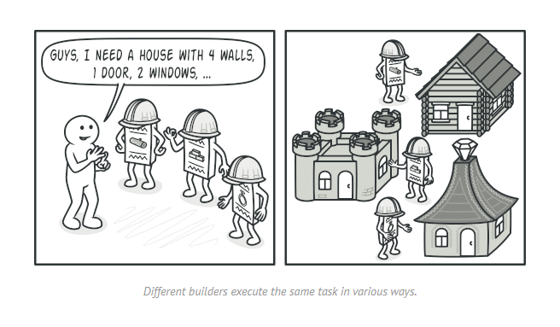

For example, imagine a builder that builds everything from wood and glass, a second one that builds everything with stone and iron and a third one that uses gold and diamonds. By calling the same set of steps, you get a regular house from the first builder, a small castle from the second and a palace from the third. However, this would only work if the client code that calls the building steps is able to interact with builders using a common interface.

1. **Structural Patterns**

These design patterns concern class and object composition. Concept of inheritance is used to compose interfaces and define ways to compose objects to obtain new functionalities.

Structural patterns explain how to assemble objects and classes into larger structures while keeping these structures flexible and efficient.

types of **Structural** Design Pattern

1. **Adapter** – Ensures that at most only one instance of an object exists throughout application
2. **Bridge** – Creates objects of several related classes without specifying the exact object to be created
3. **Composite** – Creates families of related dependent objects
4. **Decorator –**Constructs complex objects using step-by-step approach
5. **Façade –**Constructs complex objects using step-by-step approach
6. **Flyweight –**Constructs complex objects using step-by-step approach
7. **Proxy –**Constructs complex objects using step-by-step approach

* Adapter: **Adapter** is a structural design pattern that allows objects with incompatible interfaces to collaborate.

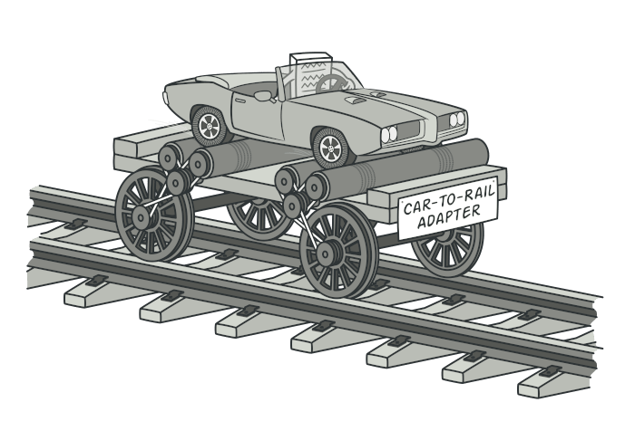

Imagine that you’re creating a stock market monitoring app. The app downloads the stock data from multiple sources in XML format and then displays nice-looking charts and diagrams for the user.

At some point, you decide to improve the app by integrating a smart 3rd-party analytics library. But there’s a catch: the analytics library only works with data in JSON format.

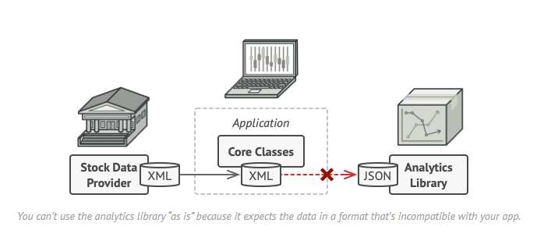

You could change the library to work with XML. However, this might break some existing code that relies on the library. And worse, you might not have access to the library’s source code in the first place, making this approach impossible.

Implementations:

You can create an *adapter*. This is a special object that converts the interface of one object so that another object can understand it.

An adapter wraps one of the objects to hide the complexity of conversion happening behind the scenes. The wrapped object isn’t even aware of the adapter. For example, you can wrap an object that operates in meters and kilometers with an adapter that converts all of the data to imperial units such as feet and miles.

Adapters can not only convert data into various formats but can also help objects with different interfaces collaborate. Here’s how it works:

1. The adapter gets an interface, compatible with one of the existing objects.
2. Using this interface, the existing object can safely call the adapter’s methods.
3. Upon receiving a call, the adapter passes the request to the second object, but in a format and order that the second object expects.

Sometimes it’s even possible to create a two-way adapter that can convert the calls in both directions.

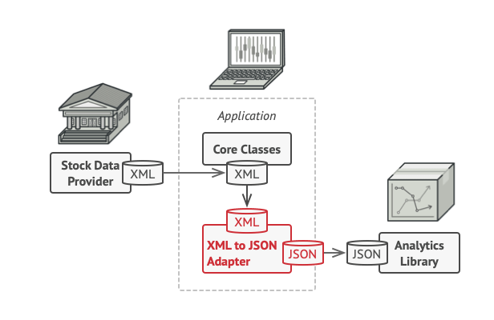

Let’s get back to our stock market app. To solve the dilemma of incompatible formats, you can create XML-to-JSON adapters for every class of the analytics library that your code works with directly. Then you adjust your code to communicate with the library only via these adapters. When an adapter receives a call, it translates the incoming XML data into a JSON structure and passes the call to the appropriate methods of a wrapped analytics object.s